Linked List

Linked List is a very commonly used linear data structure which consists of group of nodes in a sequence.
Each node holds its own data and the address of the next node hence forming a chain like structure.
Linked Lists are used to create trees and graphs.

Advantages of Linked Lists
– Dynamic in nature which allocates the memory when required.
– Efficient memory utilization
– Insertion and deletion operations can be easily implemented.
– Stacks and queues can be easily executed.
– Linked List reduces the access time.
– don't need to know the size in advance.

Disadvantages of Linked Lists
– require extra memory for pointers storage.
– No element can be accessed randomly;
– it has to access each node sequentially.
– Reverse Traversing is difficult in linked list.

Applications of Linked Lists
– Implementation of stacks and queues
– Implementation of graphs

Types of Linked Lists
There are 3 different implementations of Linked List available, they are:
- Singly Linked List
- Doubly Linked List
- Circular Linked List

Singly Linked List
Singly linked lists contain nodes which have a data part as well as an address part i.e. next, which points to the next node in the sequence of nodes.

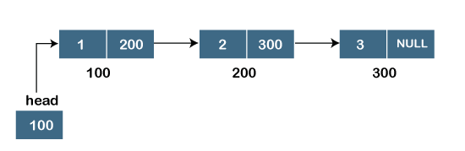

Representation of the node in a singly linked list
struct node
{
int data;
struct node *next;
}

Doubly Linked List
In a doubly linked list, each node contains a data part and two addresses, one for the previous node and one for the next node.

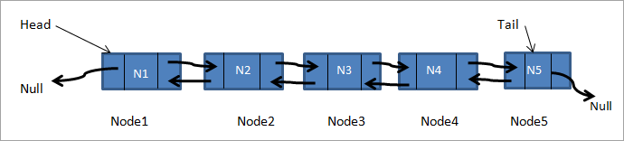

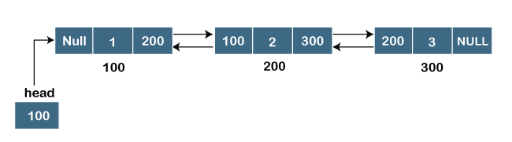

Representation of the node in a doubly linked list
struct node
{
int data;
struct node *next;
struct node *prev;
}

Circular Linked List
In circular linked list the last node of the list holds the address of the first node hence forming a circular chain

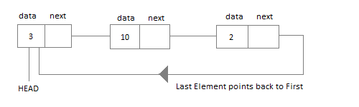

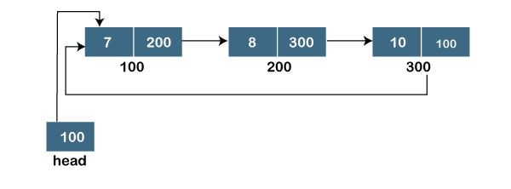

Doubly Circular linked list

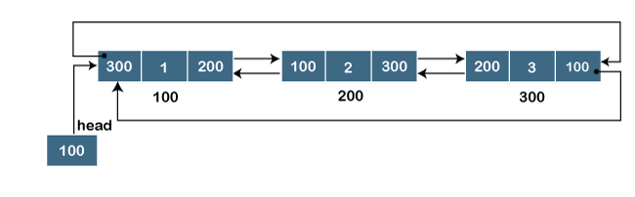

struct node
{
int data;
struct node *next;
struct node *prev;
}

https://www.javatpoint.com/singly-linked-list

https://citeseerx.ist.psu.edu/viewdoc/download?doi=10.1.1.646.9426&rep=rep1&type=pdf

